

**AMERICAN INTERNATIONAL UNIVERSITY-BANGLADESH**

**(AIUB)**

**DATA COMMUNICATION LAB**

Course Instructor : Tanjil Amin

Lab No : 01

Section : L

Date of Performance : 27-01-2020

Date of Submission : 10-02-2020

Group : 06

|  |  |
| --- | --- |
| Name | ID |
|  |  |
|  |  |
| KARMOKAR, JOY | 18-39263-3 |
|  |  |
|  |  |

**Performance Task for Lab Report:**

(a) Select the value of the amplitudes as follows: let A1 = AB and A2 = GH. For the phases, use j1 = DG (in degrees), and take j2 = 30º. *When doing computations in Matlab, make sure to convert degrees to radians.*

(b) Make a plot of both signals over a range of t that will exhibit approximately 3 cycles. Make sure the plot starts at a negative time so that it will include t = 0, *and make sure that you have at least 20 samples per period of the wave.*

(c) Verify that the phase of the two signals x1(t) and x2(t) is correct at t = 0, and also verify that each one has the correct maximum amplitude.

(d) Use subplot (3,1,1) and subplot (3,1,2) to make a three-panel subplot that puts both of these plots on the same window. See help subplot.

(e) Create a third sinusoid as the sum: x3(t) = x1(t) + x2(t). In Matlab this amounts to summing the vectors that hold the samples of each sinusoid. Make a plot of x3 (t) over the same range of time as used in the previous two plots. Include this as the third panel in the window by using subplot (3,1,3).

(f) Measure the magnitude and phase of x3 (t) directly from the plot. In your lab report, explain how the magnitude and phase were measured by making annotations on each of the plots.

1. A1=18

j1=30*(pi/180)

b=3880

t=-1.5/b:3/2000000:1.5/b

x1=A1*cos(2*pi*b*t+j1)

A2=83

j2=60*(pi/180)

x2=A2*cos(2*pi*b*t+j2)

1. plot(t, x1)

plot(t, x2)



Figure : t,x1



Figure : t,x2

1. plot(t,angle(x1)),title('Phase Plot')

plot(t,abs(x1)),title('Amplitude Plot')



Figure : Phase of (t,x1)



Figure : Amplitude of (t,x1)

plot (t, angle(x2)), title('Phase Plot')

plot (t, abs(x2)), title('Amplitude Plot')



Figure : Phase of (t,x2)



Figure : Magnitude of (t,x2)

1. subplot (3,1,1), plot (t,x1)

subplot (3,1,2), plot (t,x2)

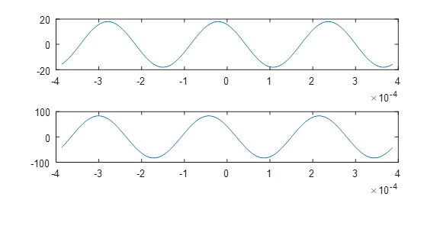

Figure : Subplot of (t,x1) and (t,x2)

1. x3 = x1 + x2

subplot (3,1,3), plot (t, x3)



Figure : Graph of x3=x1+x2, (t,x3)

1. plot (t, abs(x3)), title('Amplitude Plot')

plot (t, angle(x3)), title('Phase Plot')

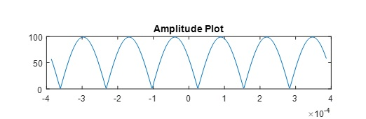

Figure : Magnitude of (t,x3)

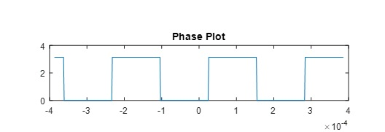

Figure : Phase of (t,x3)